

**Assessment 2**

**Group Project: Supply Chain and Operations Strategy for Secret Squirrel Winery**

Victoria Tashbaeva (230022025)

Moses Satralkar (23006716)

Thushitha Mudalige (23012423)

Tomasz Osuchowski (23016087)

Massey Business School, Massey University

115774: Operations and Supply Chain Management

Prof. Alan Win

24th April 2024

**Word count:** 4836 words (excluding cover page and references)

**Executive Summary**

Australia's wine industry is renowned for its quality, diversity, and unique terroirs. The industry has experienced steady growth, driven by investments in technology, sustainable practices, and marketing initiatives. Australian wines are popular globally, with major export destinations including the UK, US, Canada, and emerging markets in Asia, particularly China. Despite challenges such as droughts or bushfires, Australia's wine production has remained resilient, contributing to increased export volumes. The industry's value proposition is reflected in its premium prices, reflecting its quality, craftsmanship, and brand reputation. Market diversification strategies have reduced reliance on traditional markets and capitalized on emerging opportunities. In the past two decades, the Australian wine industry exemplified significant internationalisation (Fleming., et al. 2014). Effective branding and promotion have enhanced the visibility and desirability of Australian wines in export markets. Despite challenges, Australia's wine exports continue to thrive, driven by factors such as quality, innovation, and market diversification. Australia's wine industry has a 150-year legacy, that positions Australia with other key wine makers in the global market, providing an international perspective on its expansion particularly in the past decade (Anderson, 2000).

Australian global wine exports experienced a 3% drop in value and 607 million liters in value in December 2023, with Asia being the main destination, accounting for 37% of exports. Europe and North America saw a 7% and 12% drop respectively. However, Oceania saw a 3% increase in value. Australia's wine export mix has seen a decline in shipments to China and the US, but increased export values to Hong Kong and developing Asian markets like Singapore (Wine Australia, 2023). The global glut of bulk wines, particularly in red varieties, affects market dynamics and prices. However, promising signs exist for Australian wine exports to developing nations near Australia, with a 12% increase in wine grape output in 2023-2024. Despite constant pressure, developing markets and the luxury wine category offer bright prospects for development and expansion. The global wine market has gone through major changes in recent years. Some of these changes are structural in nature or trend-following, whereas others are cyclical. Recently, new market entrants have increased their exports not only to European markets but also to Asia as well (Walter and Cohen, 2006).

The Secret Squirrel Winery in Australia has been doing reasonably well in exporting and distributing its selections of 3 product lines out of 9 red and white varietals for the past eight years to major locations around the world. The exports included 53% to the UK, 25% to Europe, 14% to Canada, 5% to China and 3% within Australia. However, the company has to grow 20% within the next 2-3 years.

Our firm “World Class Consulting” is analysing the case-study of this company. We suggest switching to “bottle at destination” model for UK and EU volume, utilizing a common strategy for bulk wine producers. Bulk wine production and shipping promotes economy of scale business, and the “bottle at destination” strategy, which is cost effective and sustainable with multiple elements of business optimization as the result. On top of that, we propose a new expansion strategy for the APAC region with the introduction of prospective markets to enter. We believe our overall proposed strategy will be more suitable for SSW in their pursuit of growing the business by 20% in the next 2-3 years.

**Solution Introduction and Analysis of the Case**

***Analysing Australia Bulk Wine Export***

In the past decade leading up to 2023, Australian wine exports ranged from $ 619 million to $849 million liters annually, valued between A$1.79 billion and A$2.91 billion FOB. In 2023, Australian wine exports dropped 2.4% in value to $1.9 billion and a 2.5% reduction in volume to 607 million liters. The ongoing decline in numbers stemmed from the reduction in global consumption as consumers started to cut back on their discretionary spendings. This is occurring simultaneously with consecutive years of a global oversupply of wine (Wine Australia, 2023).  There are 1,298 wine exporters in Australia, trading with 112 destinations. Top five export destinations in 2023 were US, UK and EU, Hong Kong, Canada and Singapore. While Hong Kong and Singapore ranked as the top export destinations, much of the wine sent to these major trading hubs is further distributed to other markets (Wine Australia, 2023).

Figure 1: Export value by destination region in 2023 (source: Wine Australia, 2023)

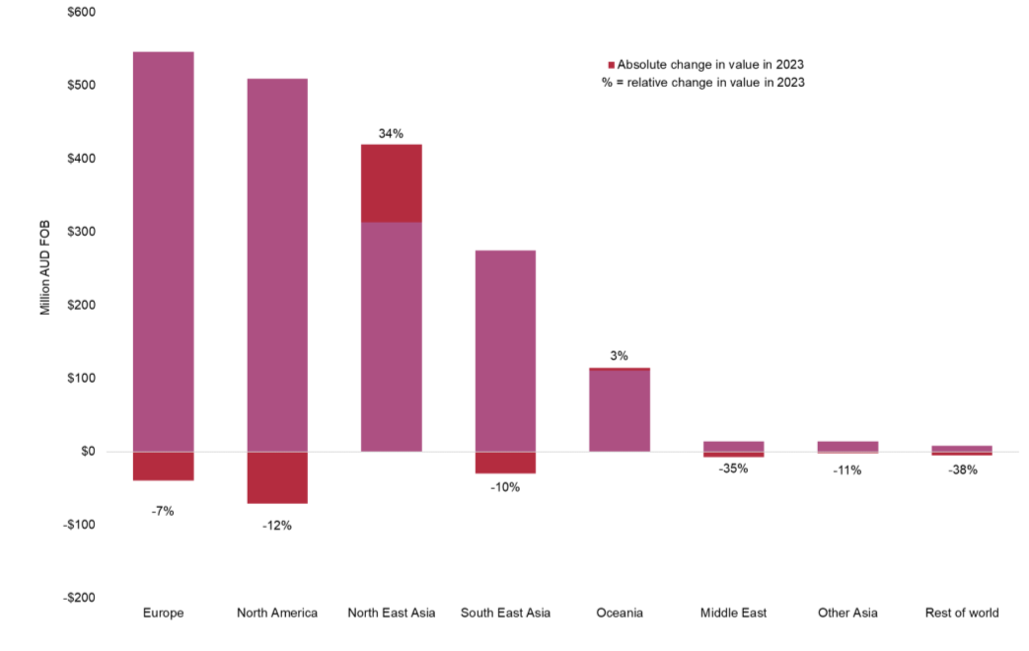

Approximately 60% of Australia's annual wine production is exported, with 69% of the export shipped in bulk (to be packaged at destination) in 2023 versus 53% in 2013. In 2023, Australia’s bulk wine exports valued at AUD 473 million with 418 million liters, while bottled still white wine exports fell by 10%, and bottled red wine by 14% in volume. This shift from bottled to bulk exports is motivated by economic and environmental considerations, allowing companies to ship more wine at lower costs (Wine Australia, 2023).

Figure 2: Volume share of Australian wine exports by packaging type (Wine Australia, 2023)

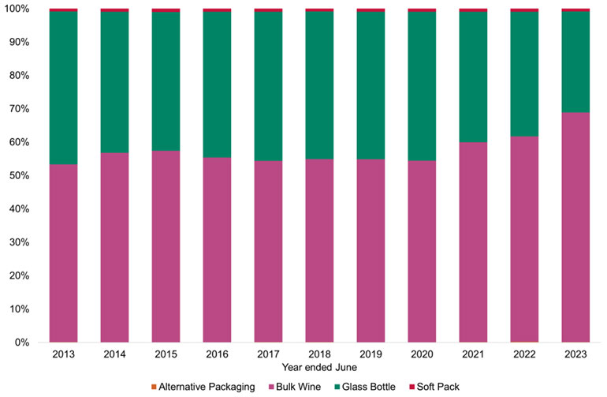

The 2023 Wine Business Monthly Packaging Survey in the US found that glass costs rose by 8%, prompting 43% of wineries to focus on cost control in packaging. About 31% of US wineries have shifted to lighter glass bottles to cut costs, with many others already using the lightest options available. Reasons for this switch include emission reduction, lower bottle and transport expenses. However, some worry that lighter bottles might compromise brand prestige. Consumer trends toward health and wellness are also influencing packaging choices. As people seek to moderate alcohol consumption, packaging options supporting this trend gain traction. Wine drinkers in Australia, the UK, the US, and Canada are increasingly aware of alternative packaging sizes beyond the standard 750ml bottle. In the US, awareness of various packaging types surged in 2022, with pouches gaining popularity in Australia and the UK, and single-serve bottles in Canada. For both Australia and the UK, there was growth in both larger and smaller formats. For example, in Australia large 5 litre casks grew in volume and value year-on-year, while in the UK magnums (1.5 litre bottles) and 3 litre casks drove growth. However, 187ml bottles also experienced growth in both markets, off small bases. Meanwhile, in North America, the 500ml format, which is mostly mini casks/tetra packs, showed growth in the US, while the 375ml size format grew in Canada. (Wine Australia, 2023).

***Australia - United Kingdom and EU Wine Trade in Bulk shipping***

The United Kingdom (UK) stands as the world's second-largest wine market by value and fifth largest by volume, heavily reliant on imports. Australia is its largest wine supplier by volume and second largest by value, after the United States. In 2023, Australian wine exports to the UK declined 3% in value to $361 million but increased 2% in volume to 220 million litres, marking the first volume growth since mid-2021. Bulk shipments now make up 85% of Australian exports to the UK (Wine Australia, 2023). The value decline was driven by a 14% drop in packaged wine exports, while unpackaged wine exports rose 4%. Red wine exports increased their share, while white wine exports decreased slightly in volume share. Despite a 3% decline in volume, Australia maintained 2% growth in value in the UK off-trade market, possibly influenced by the UK's high inflation rates (Wine Australia, 2023).  Additionally, Australia exports wine to key European markets including Germany, Denmark, the Netherlands, and Sweden. In 2023, exports to Europe declined by 14 per cent in value to $184 million and 7 per cent in volume to 89 million litres, driven by inflation and supply chain issues due to the Red Sea conflict (Wine Australia, 2023).

Figure 3: Value of exports to the United Kingdom over time (Wine Australia, 2023)

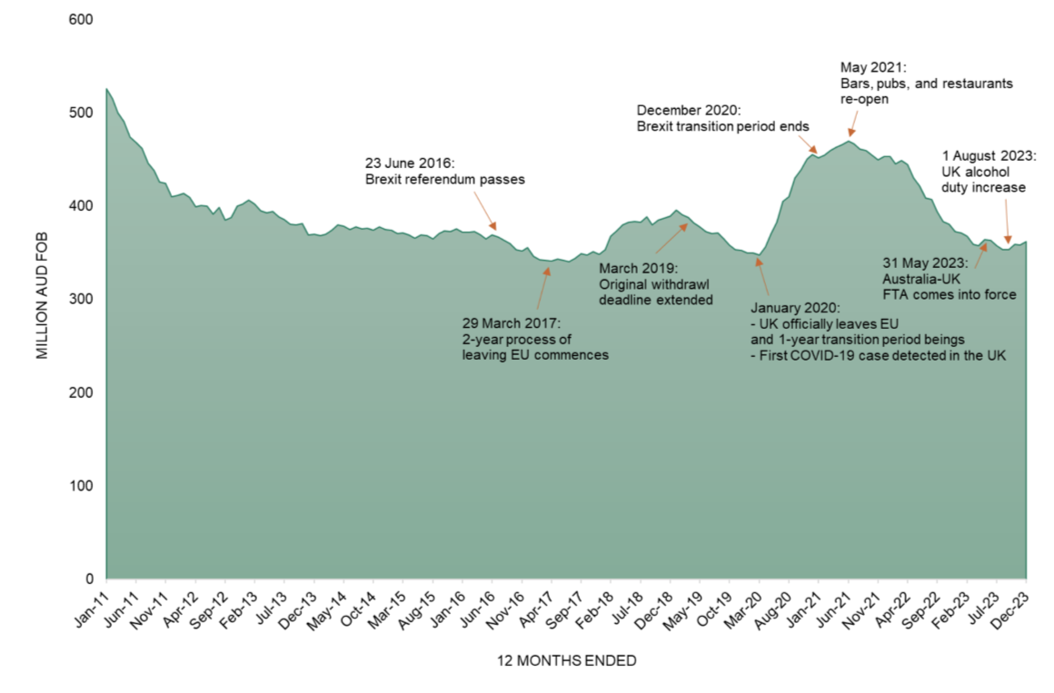

Figure 4: Exports to Europe (excluding the UK) by destination market

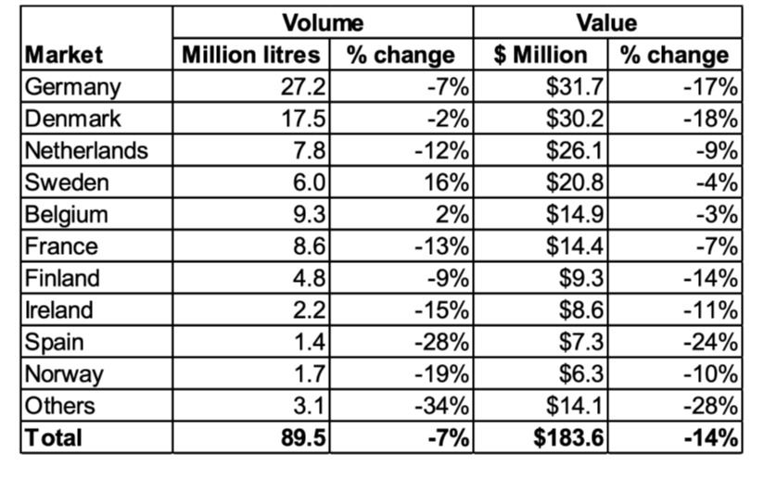

While Australia remains the most price-competitive red wine supplier in the world, the current global wine market landscape continues to be challenging. Global wine production has been higher than consumption in recent years and 2023’s output exceeded demand by approximately 10%, even with output coming in below average for the fifth year in a row (Ciatti, 2024). With the export declined along with the remaining inventories to clear, winemakers are looking for efficient ways to sustain the business.

**Introducing Bulk Wine Export Strategy: Bottling at Destination**

Secret Squirrel Winery (SSW) is an international wine distribution company, based in Clare Valley, South Australia. SSW current sales is A$ 109.5 million, accumulated from export in the UK, EU, China, Canada and by domestic market contribution.

Outside Australia, SSW is contracted by wine distributors and retail chains to produce wine for private labels with specific composition characteristics. SSW current operations model is “bottle at source”, where wine is produced and bottled at the estate and shipped in the standard 20 ft. containers carrying 9L cases by sea freight. The major drivers of the cost in the current model are storage, packaging and transportation, and marketing

Our solution suggests switching to “bottle at destination” model for UK and EU volume, utilizing a common strategy for bulk wine producers. Bulk wine production and shipping promotes economy of scale business, and the “bottle at destination” strategy offers cost effective and sustainable model of operations with multiple elements of business optimization as a result.

***Solution implementation: Bottling at Destination***

At the current volume contracted, we suggest piloting the new “bottle at destination” strategy for the entire UK and EU markets volume.  SSW largest client in the UK is the retail chain Tesco, the new strategy allows to capitalize and expand these existing relationships. Supermarkets in the UK and EU are powerful players in the global wine value chain for New World and wine-exporting countries. Retail giants like Aldi in Germany and Tesco in the UK, in collaboration with bottling companies, have rapidly emerged as major global wine producers and distributors, introducing private-label wines as common practice in the industry. As of today, 78% of wines in Germany are sold through supermarkets, with 46% being private-label brands. Additionally, some of these private-label wines are re-exported to regions like Scandinavia and Eastern Europe (Rainer et.al., 2021). In the UK, Tesco, Sainsbury's, Asda, and Morrisons dominate supermarket wine sales, accounting for 70% of the total, with Tesco alone contributing 33% (Gwynne, 2008).

As shown in the previous sections, bulk wine is a common export category, where wine is transported in ISO tanks and Flexitanks fit in the containers to local distributors and retail private labels bottlers, which sit at the end of the bulk supply chain. A conventional twenty-foot container holds approximately 13,200 bottles or 9,900 liters of wine, whereas a Flexi tank can accommodate over 24,000 liters, more than doubling the volume. By avoiding the transportation of the comparatively inefficient packaging, high deadweight, and additional volume of bottles, this not only cuts costs but also expedite the delivery and reduces carbon emissions by up to 40%, or about 2kg of CO2 per kilometre travelled, compared to traditional wine transport (Rainer et.al., 2023). Additionally, bulk liquid transport offers the advantage of greater thermal stability due to thermal inertia. A 24,000-liter Flexi tank heats up much slower than a one-liter wine bottle, making it less susceptible to sudden temperature changes (Aaltonen, 2015).

Figure 5: Flexitanks for storing and transporting wine in ships and trucks

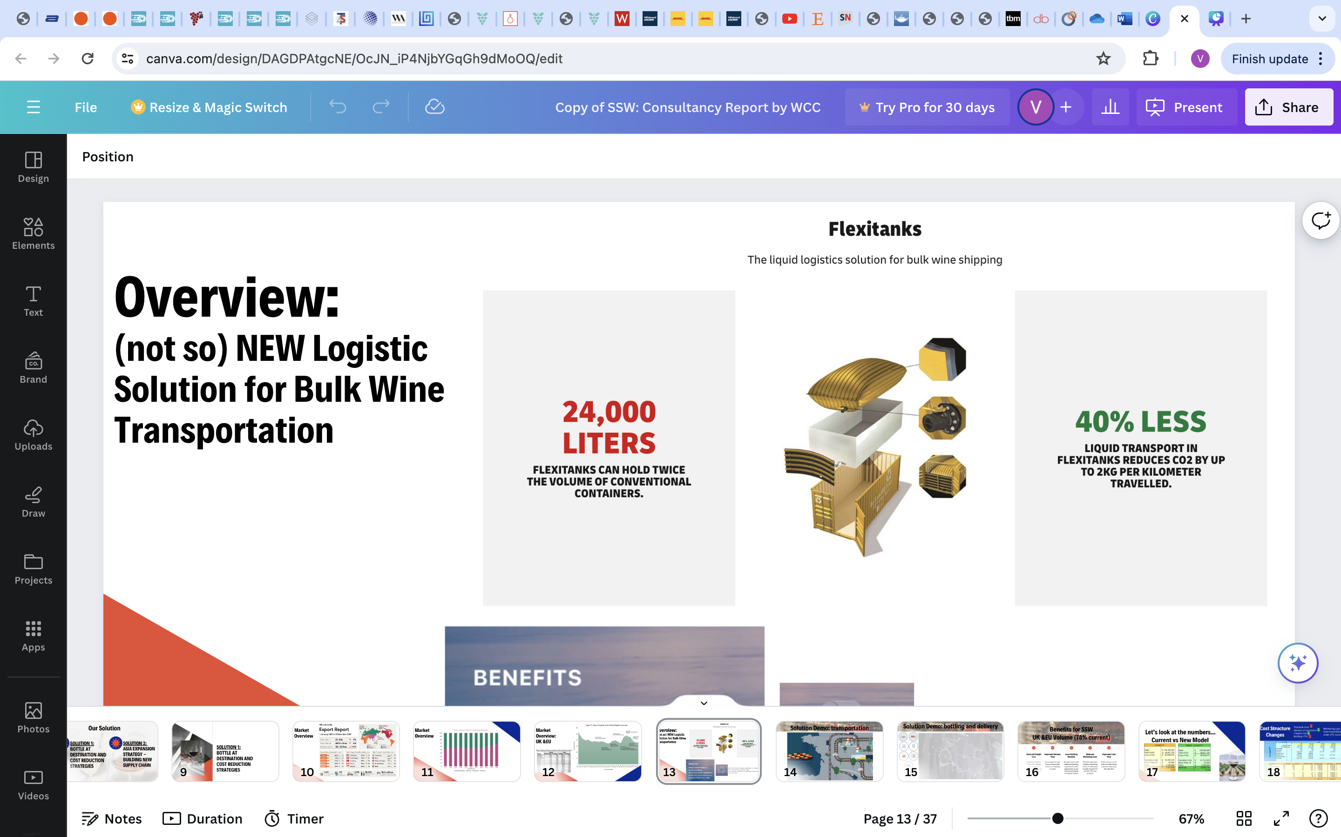

It reduces the number of containers required to ship the annual order, providing significant saving on freight cost. Also, removal of bottling and ready-for-shipment storage for UK/EU volume will free up space for new volume development and bottling at source for new market expansions. Despite the 7% increase on bottling cost for UK/EU volume, which is considered in our calculations below, there is an opportunity to reduce this cost by diversifying the packaging options bottled at destination, for example consider lighter bottles instead of the original bottle type, which is used in our calculations. For the bulk shipment to UK/EU, it is also suggested to change the marketing incentive from fixed $10.5 per case to percentage on order size, in particular 7% for the current product line. This marketing incentive strategy is commonly used among bulk exporters, as they trade in litters for low priced wine category, which is the case for SSW UK/EU export.

***Finacial projection: Bottling at destination***

Since the solution propose the change only for UK and EU markets, the rest existing countries (China, Canada, Australia) stay the same in terms of the cost structure. Improved budget contains combined effect from UK/EU cost optimization and current cost structure for the rest of the countries. Below, in Tables of Figure 6 A, B and C, results are presented.

Figure 6A. Financial Results Comparison, Current vs under new solution

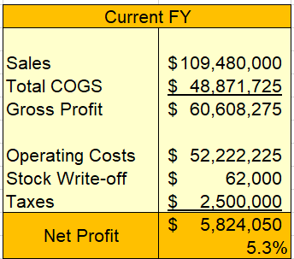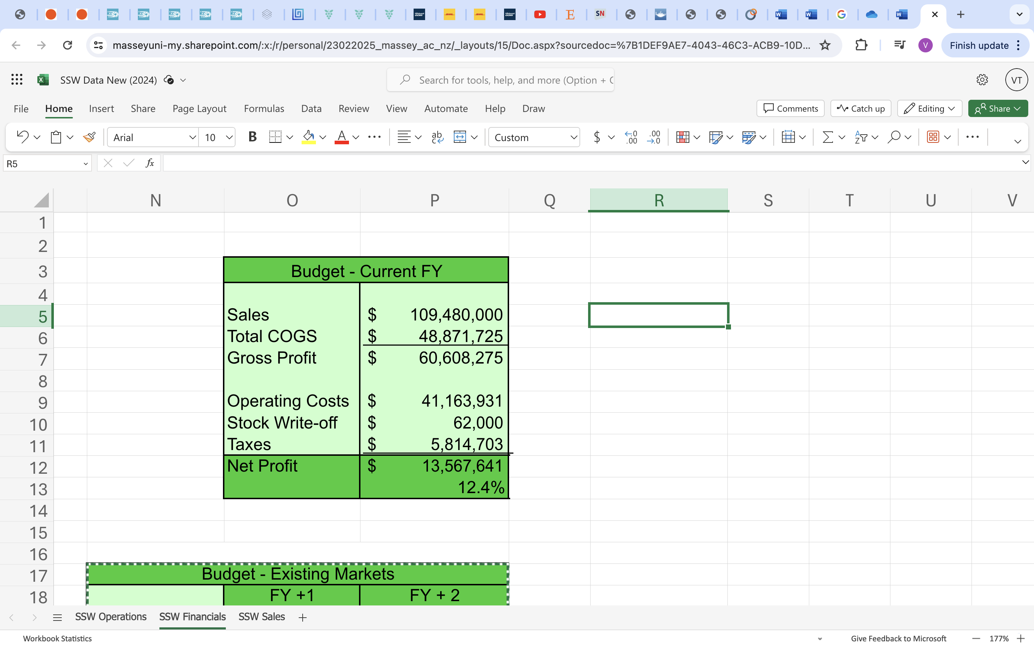  
Figure 6B. Financial Results Comparison, Current FY1/FY2 vs New FY1/FY2

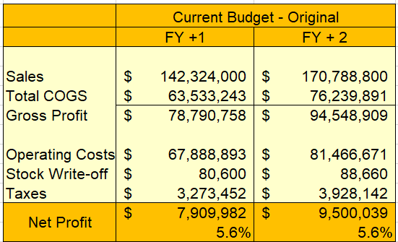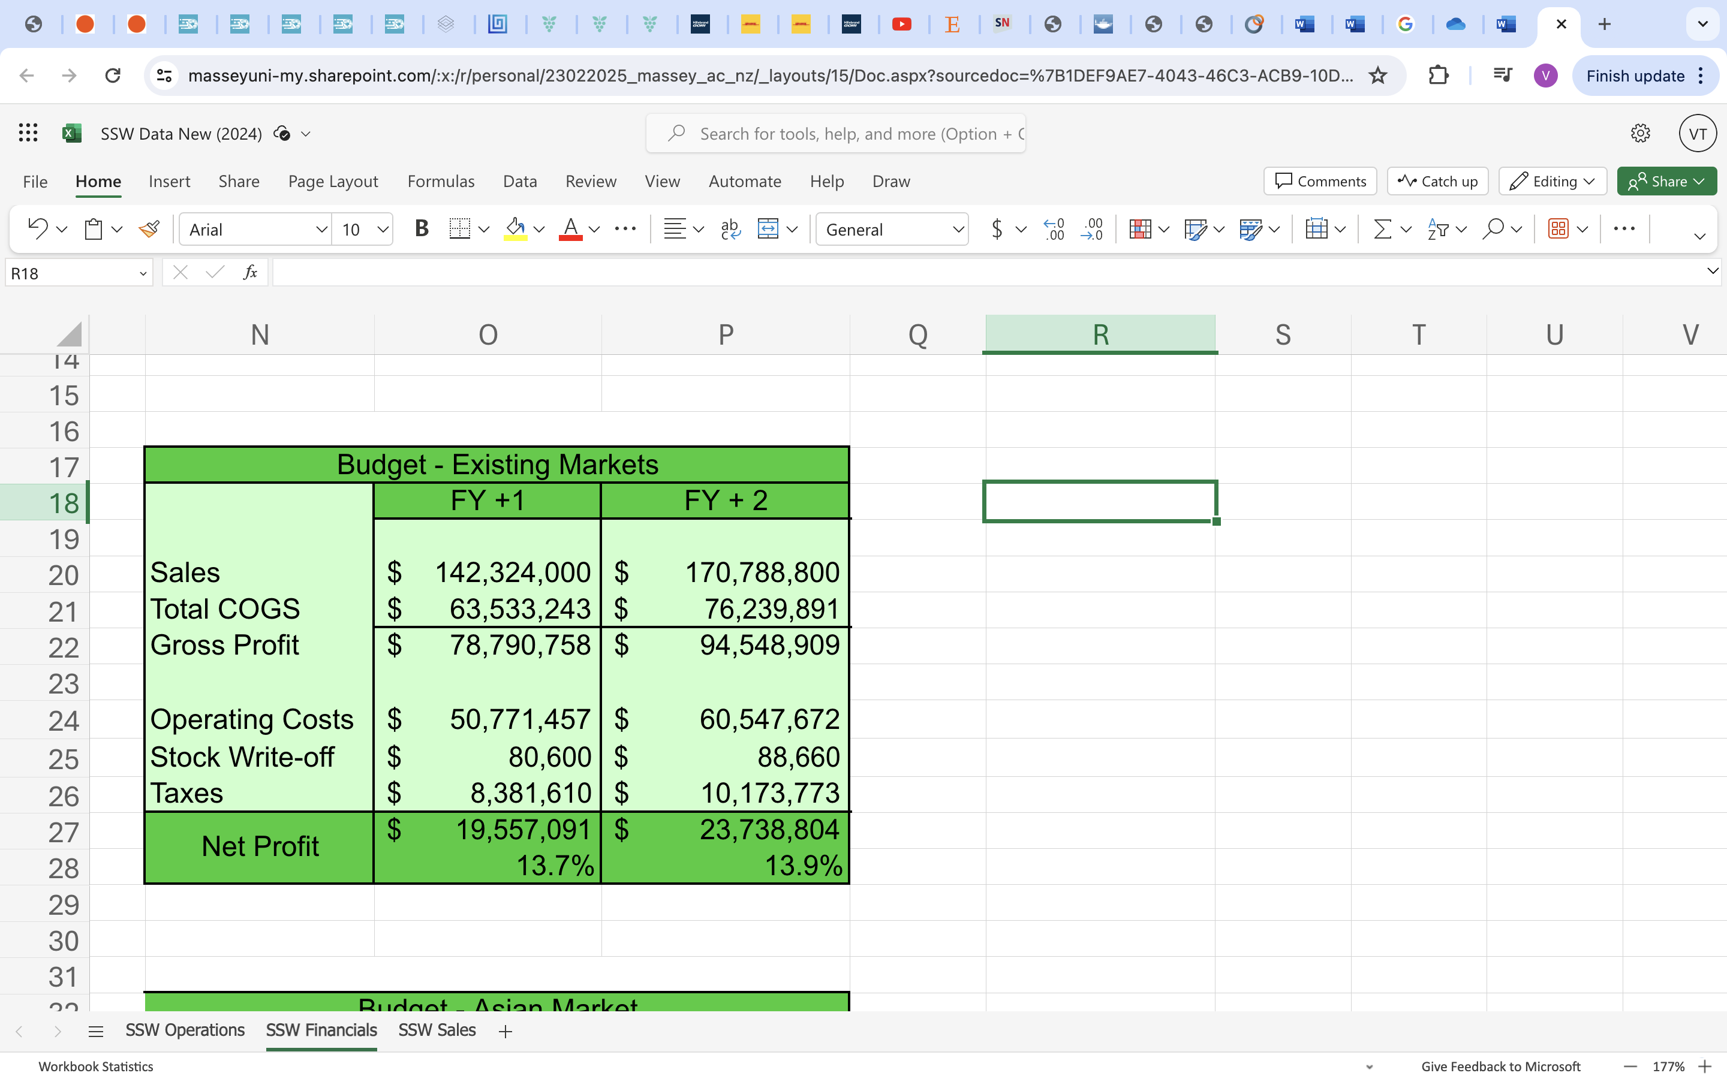

Above tables in Figure 6A. reflect the effect of operating cost optimization by the proposed solution, applied to the current year sales. As shown, it significantly improves the bottom line, delivering the profit margin improvement from 5.3% to 12.4%. Tables in Figure 6B. illustrate the effect of operating cost optimization with the proposed solution, applied to the next 2 years projected sales volume. With the sales growth year over year, it allows to reach significant increase in net profit, delivering 13.7%-13.9% profit margin.

In the tables below in Figure 6C cost and COGS breakdown calculation details are presented for supporting purpose.

Figure 6C. Cost breakdown and COGS, Current vs FY1 vs FY2

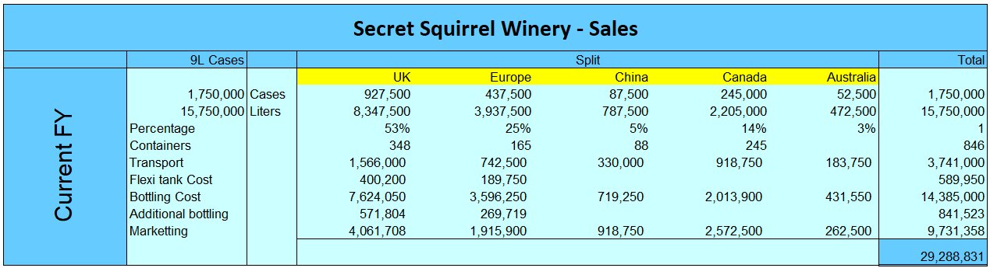

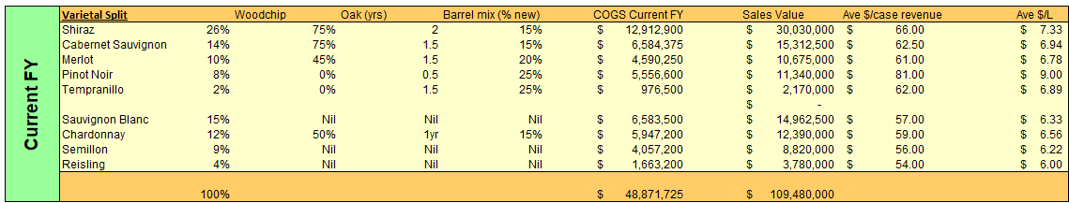  
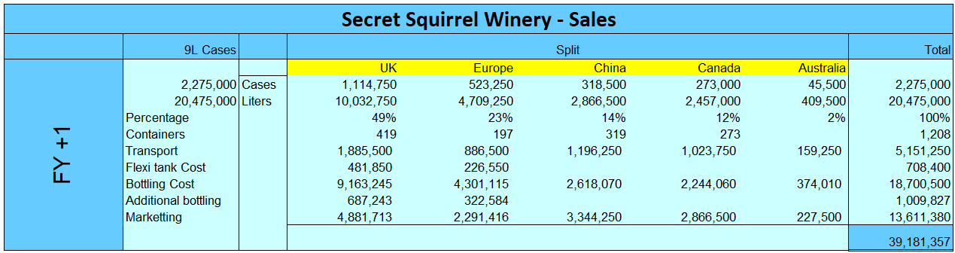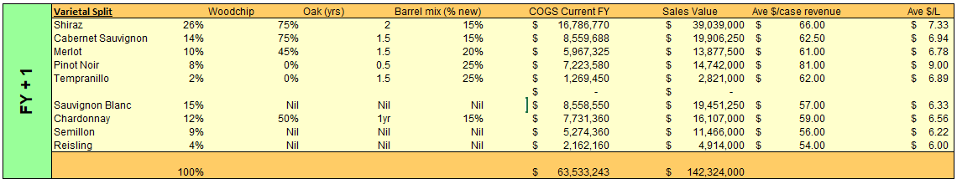  
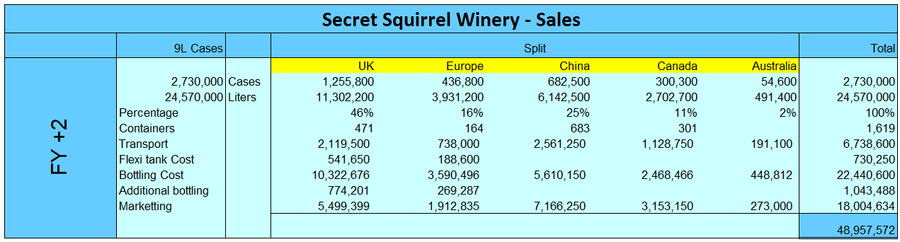  
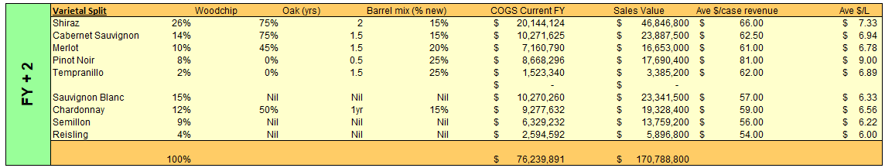

**Introducing Asia Market Expansion Strategy**

***Southeast Asia and Asia Pacific Countries***

Market research evidence shows that Australian wine exports to new international destinations particularly those in Southeast Asia and Asia Pacific have seen steady growth over the past decade due to rising demand for premium products among affluent consumers. Since Asia’s beverage production has not kept up with its expansion in demand, alcohol imports are increasingly filling the gap, particularly wine (Anderson, 2020). According to the United Nations, Asia, which includes Northeast Asia, Southeast Asia, and other Asian countries, has about 50 separate markets with a variety of unique cultural, religious, and social customs (Wine Australia, 2023). Despite the continent's enormous population, the majority of the over 20 wine markets are very tiny, with low per capita consumption. China, Japan, and South Korea have the biggest wine markets, whereas South Korea, India, and Thailand have the fastest-growing markets. A research projects Asia to dominate the global wine consumption and import growth in the next decade (Anderson and Wittwer, 2015).

Figure 7: Top 20 destinations by number of exporters in 2023

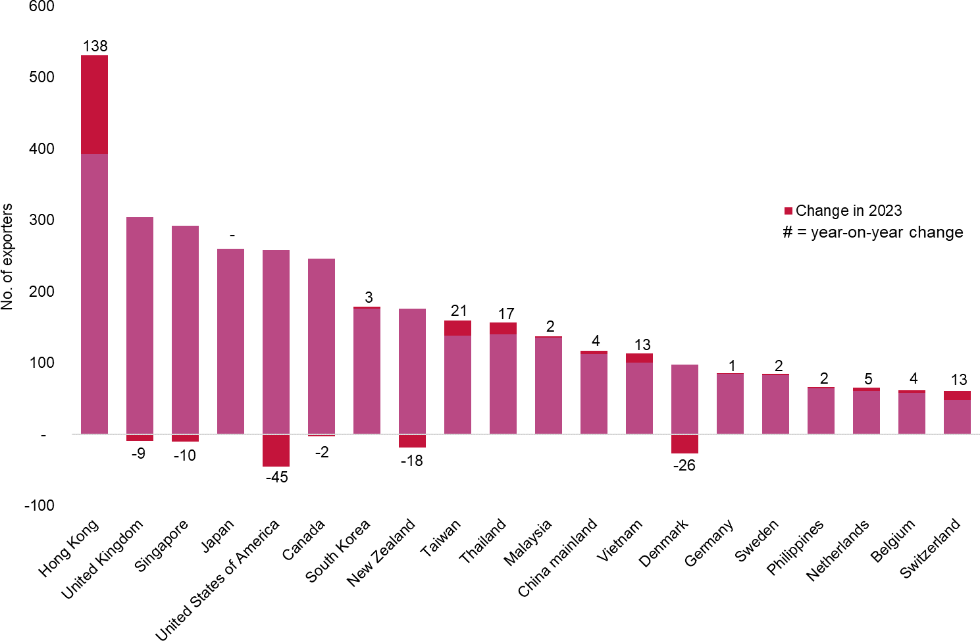

As seen in Figure 7 above, in the year that ended in December 2023, out of the top 20 markets, Hong Kong and Singapore saw the biggest increase in exporters, followed by Taiwan, Thailand, and Vietnam (Wine Australia, 2023). With a 37% value share, Asia is currently the largest area for Australian wine exports, with a robust 34% increase into Northeast Asia. The value share of North America and Europe has already decreased to 27 and 29 percent, respectively (Wine Australia, 2023). The United States, Denmark, New Zealand, Singapore, and the United Kingdom were the top destinations that lost exporters. In terms of the overall number of exporters, Japan now leads the US. As significant commercial hubs, Hong Kong, the UK, and Singapore were the top three destinations for exporters; however, some of this wine was redistributed to other markets. Australian wine was shipped to 112 locations in the 12 months ending in December 2023. Moreover, research has shown Australia’s wine exports are not very responsive to changes in export price. The trade liberalisation shows a positive impact on the supply of wine exports; hence Australia has some unique market power in relation to its exports of differentiated or unique wines to the world market (Boriraj, 2008).

Figure 8: Australia’s current top Wine Export destinations in Asia

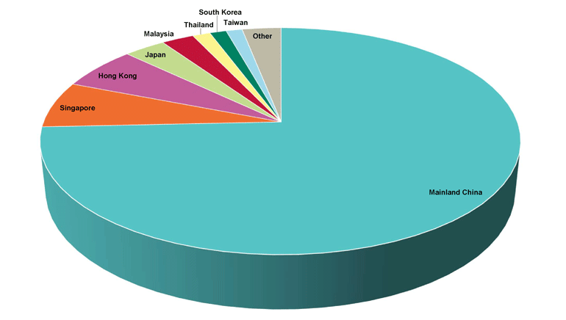

Key markets identified by us include Singapore, Thailand, South Korea, Japan, Indonesia, Malaysia, and Vietnam, driven by changing consumer preferences, growing disposable incomes, and a burgeoning food and beverage culture (Wine Australia, 2023). However, Australian wine exporters face challenges such as established competitors, differing regulatory frameworks, religious restrictions, trade limitations as well as cultural preferences, hence it may be essential to use redistribution model in certain markets. Opportunities for market expansion include leveraging Australia's reputation for producing high-quality, sustainable wines, engaging with local distributors, retailers, and hospitality establishments, and embracing digital marketing channels and e-commerce platforms.

This is also keeping abreast growth of Australian wine exports to Asia which shows that volume shares of the three main wine types: red wine, which is at 51%, white wine, which is at 46%, and rosé, which is at 3% have not changed during the last 12 months in 2023 (Wine Australia, 2023). As per research by Wine Australia, 2023, the top five kinds of still red wine products shipped were:

- Shiraz, which decreased by 9% to 133 million liters;

- Cabernet Sauvignon, which increased by 2% to 85 million liters.   
- Merlot, which increase by 3% to 39 million liters;  
- Pinot Noir, which decrease by 15% to 4.3 million liters;

- Petit Verdot, which decrease by 17% to 3.2 million liters.

Nevertheless, white wine exports fell by 2% in volume to 271 million liters and 3% in value to $547 million. White wine in packages decreased by 10%, more than offsetting a 1% gain in unpackaged wine. In 2023 Wine Australia also enlisted the top five kinds of still white wine products shipped that were:

- Chardonnay, which decreased by 9% to 146 million liters;  
- Pinot Gris/Grigio, increasing by 21% to 47 million liters;  
- Sauvignon Blanc, which decreased by 0.2% to 27 million liters.

Health benefits of red wine were shown in culturally diverse ethnic groups (Yung, et. al, 2013). Hence, data shows increase in red wine consumption as compared to white wine in Asia.

Figure 9. Red Wine consumption in Japan.

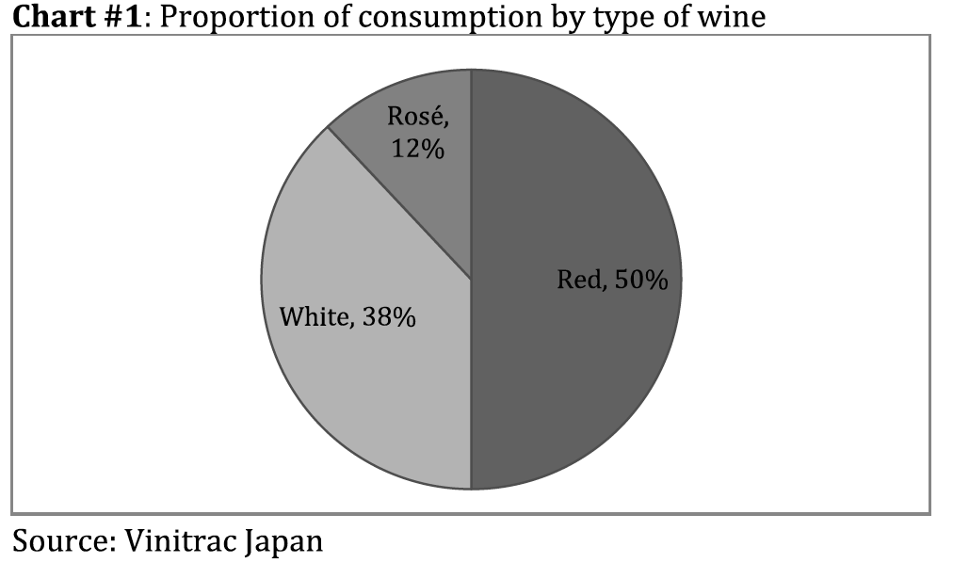

Adapting to the diverse preferences and cultural dynamics of Southeast Asian consumers is crucial for our company success. Tailoring product offerings, marketing strategies, branding initiatives, and wine education programs can enhance the appeal of Australian wines. In recent years, Australian wine exports to Asian nations with a particular emphasis on Singapore, South Korea, Japan, Indonesia, Vietnam, and Thailand have seen both substantial development and difficulties. Australian wine growers now consider the area a vital market, particularly considering the drop in shipments to China. As per 2023 Wine Australia export reports, presented below are recent patterns of Australian wine exports to these nations.

*Singapore*

Due to a change in wine consumption among the increasing middle class, Singapore has become a major market for Australian wine. Singapore has seen a rise in the popularity of Australian wines, which is indicative of the region's overall trend of diversification and rising wine consumption. Notwithstanding, several obstacles continue to exist, including the need for competitive pricing and efficacious marketing tactics to captivate the younger population. Singapore has free trade agreements with Southeast countries like Vietnam, Indonesia, Malaysia and Thailand and can be used as a hub for redistribution of Australian wine to these countries. As the number of wine collectors and aficionados increases, Singapore is vying with Hong Kong to become Asia's wine capital. This region of the world's wine market is expected to grow significantly. Australia's competitive advantage is outlined by its near proximity and connectedness, great brand awareness, and high level of familiarity with Singaporean customers. Australia shipped a record 8.7 million liters worth about $195 million to Singapore in 2021.

*Hong Kong*

After more than 150 years of British colonial control, Hong Kong was returned to the People's Republic of China (PRC) at midnight on July 1, 1997, and became the Hong Kong Special Administrative Region (SAR) of the PRC. The capitalist system in Hong Kong has produced an affluent lifestyle for most of its citizens and the GDP per capita based on Purchasing Power Parity (PPP) is ranked amongst the top countries in the world. Hong Kong will be used as a hub for redistribution of Australian wine to Northern regions, focusing on Japan and South Korea.

Vinexpo Hong Kong, a sizable group of Australian wine exhibitor conducts the China Roadshow, the largest exhibition of Australian wine traveling for redistribution throughout China. This expo takes place in Shanghai, Shenyang, Jinan, and Wuhan every year in June. The $50 million Export and Regional Wine Support Package (the $50m Package) made possible by the Australian government is a source of great satisfaction to fund these events. Australia's standing as the "Country of Honour" at Vinexpo Hong Kong has been exceptional in the past, with a record 151 exhibitors presenting more than 225 Australian wine brands from 51 wine regions (Wine Australia, 2023).

*South Korea*

For Australian wine exporters, there are advantages and disadvantages in South Korea. Although many companies have their eye on the market, expansion has been hindered by competition at the standard and premium levels. Despite this, Australian wineries have a chance to enter the market by interacting with regional customers and providing distinctive wine options that suit changing tastes.

*Japan*

Despite diminishing trends in wine consumption, Australia's wine sector still enjoys a sizable market share in Japan. Australia's wine exports to Japan have had difficulties over the years, with volume falling. Australian wineries who want to stay in the Japanese market must negotiate the country's commoditized wine scene and concentrate on creating high-end products that appeal to Japanese Customers.

***Trade Policies***

Australia has free trade policies with South Korea, Japan, Hong Kong and Singapore (Wine Australia Trade Agreements, 2023). Our solution will focus on Singapore and Hong Kong as redistribution hubs. Singapore has bilateral free trade with these countries. Hong Kong has liberal trade policies with these countries.

Australia enjoys a positive commercial relationship with Singapore, and on July 28, 2003, the two nations signed the Singapore-Australia Free Trade Agreement (SAFTA). In February 2009, Australia and New Zealand signed the AANZFTA, a free trade agreement with ASEAN (Wine Australia, 2023). Like SAFTA, the tariff commitments are the same.

On January 17, 2020, the Australia-Hong Kong Free Trade Agreement (A-HKFTA) came into effect. While wine imports are currently duty-free, the Free Trade Agreement guarantees that this will not change for Australian wine. There is a wine-specific annex (Annex 5-A) to the agreement. While wine imports are currently duty-free, the Free Trade Agreement guarantees that this will not change for Australian wine.

***Strategic Recommendations for APAC Expansion***

After analysis of the data and market trends, the strategic recommendation is to focus on premium wine product line export to Singapore and Hong Kong: with Singapore serving as a hub for Southeast Asia countries, and Hong Kong serving as a hub for North Asia, including South Korea and Japan. Indonesia, Vietnam and Malaysia will not be considered for direct export due to high tariffs or religious restrictions on the population or trade limitations for wines from Australia. However, Singapore will target to redistribute wine to these countries as it has better trade agreements.They also have a range of distributors in the market and short pre-established shipping routes providers. This makes the logistics of supply chain feasible.

As evidenced, Asia Pacific and Southeast Asia countries mainly consume red wine as compared to white wine. The marketing strategy is that the most premium segment of Winemakers selection and Chairmans Single Vineyard Selection wines will be exported to the new markets. Since only premium wines are being exported even a limited quantity gives a high return due to the high premium. Moreover, these wines have a better sales capacity and profit margins. Asian market’s consumer preference leans towards more premium wine product, and with a growth in disposal income and wealth concentration in the region, the consumers can afford to pay the premium price.

Selection criteria for the right distributors in Singapore and Hong Kong is an extensive portfolio and experience in redistribution across the region. Knowing the distinctive features of each market, establishing rapport with distributors, customizing marketing plans, matching product portfolios to regional tastes, and adhering to trade policies, ship routes, marketing, labelling, and packaging regulations will be customized. The advantages of exports to Asian countries are considerable with excellent trade policies and well-established short supply chain shipping routes from Australia to the East in comparison to other global markets in the West. Moreover, the population demographics in the East are higher than the West.

Current marketing incentive structure of $10.5 per case will be applicable for the Asia plan, so new distributors able to reach out and organize sales activity of the new premium wine product for their partner’s portfolio. Marketing fund provided could be used to arrange wine tasting events, digital marketing outreach, food festivals, stocking in supermarkets or restaurants or five-star hotels, internet, radio and outreach ads in Magazines or Newspapers to create awareness and organize maximum sales.

Most importantly the cost of shipping due to the proximity is lower in comparison to other routes. Bottles will be shipped directly in containers in large commercial ships.

The project will take 3-6 months to implement. The shipping company has to be contacted. Supply chain routes are to be established, with costs evaluated for routes from Australia to Singapore and Hong-Kong. Shipments take 2-6 weeks to reach both ports.

Below is the list of distributors in each sector, as well as detailing for shipping routes.

Names of top Wine Distributors and Redistributors in Singapore:

* Winehours PTE Ltd
* Beautiful Wine
* Golden Hung Ho
* Infinite Supply PTE Ltd
* Jupiter 57
* KOT Selections

Names of top Wine Distributors and Redistributors in Hong Kong:

* FICO International
* Abbelio Wines
* Amorrosso Fine Wines
* Boutique Wines
* Kedington Wines
* Jointek Fine Wines

Figure 10: Shipping routes and duration from Australia to Singapore and Hong Kong (main hubs)

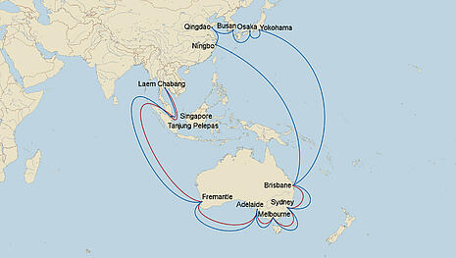 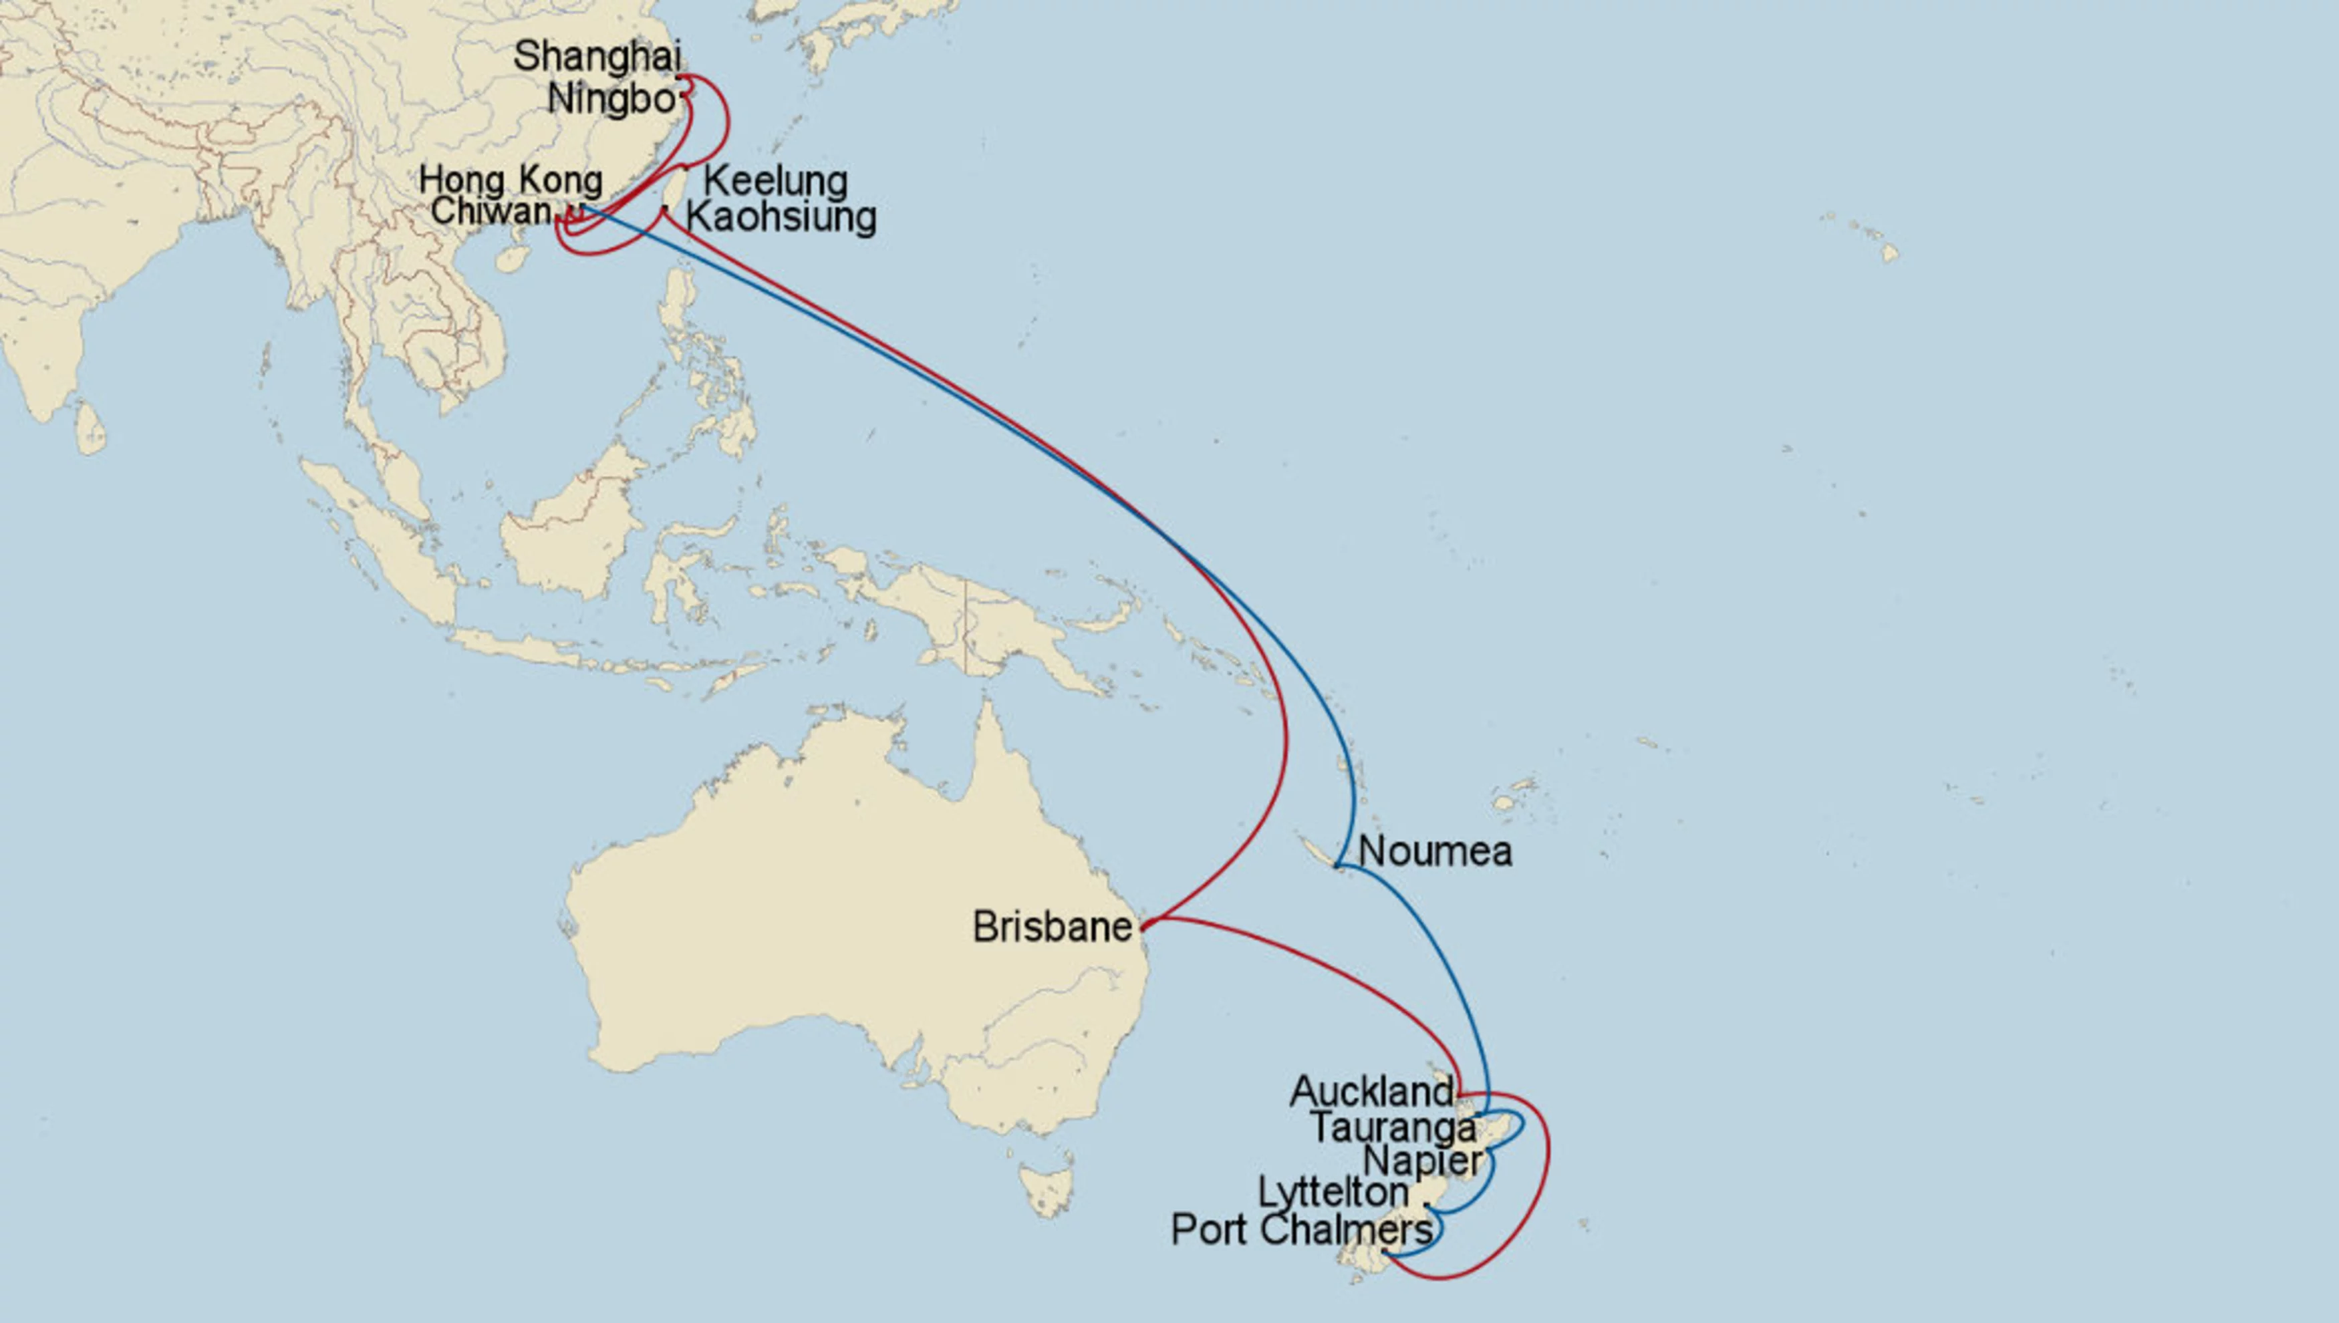

Australia to Singapore – 2-5 weeks Australia to Hong Kong – 3-6 weeks

Figure 11: Wine Redistribution

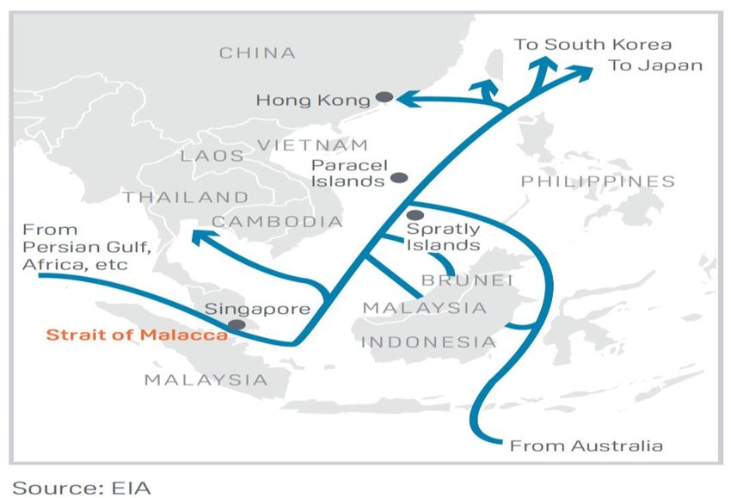

Hong Kong to South Korea and Japan Singapore to Southeast Asia

Redistribution routes (1-2 weeks) Redistribution routes (2-3 weeks)

***Financial results***

Tables in Figure 12 A, B and C outline the project budget for the new destinations for wine export. Initially for the first year we have forecasted 150,000 cases for the new markets we introduced in this report split by 50% for each destination. For second year we forecasted 201,250 cases which split into 40% for the Hong Kong and 60% for Singapore. Moreover, premium wine such as Winemakers Selection and Chairmans Single Vinyard Selection been proposed for these markets which has caused significant growth of the revenue due to their higher price points. After careful studies and market research, we were successful to derive the additional $8,254,827 for the first year and $11, 073,257 for the second year in the net profit from the New Asian markets we proposed as shown in Figure 12A below.

Figure 12 A – Budget for Year 1 and Year 2

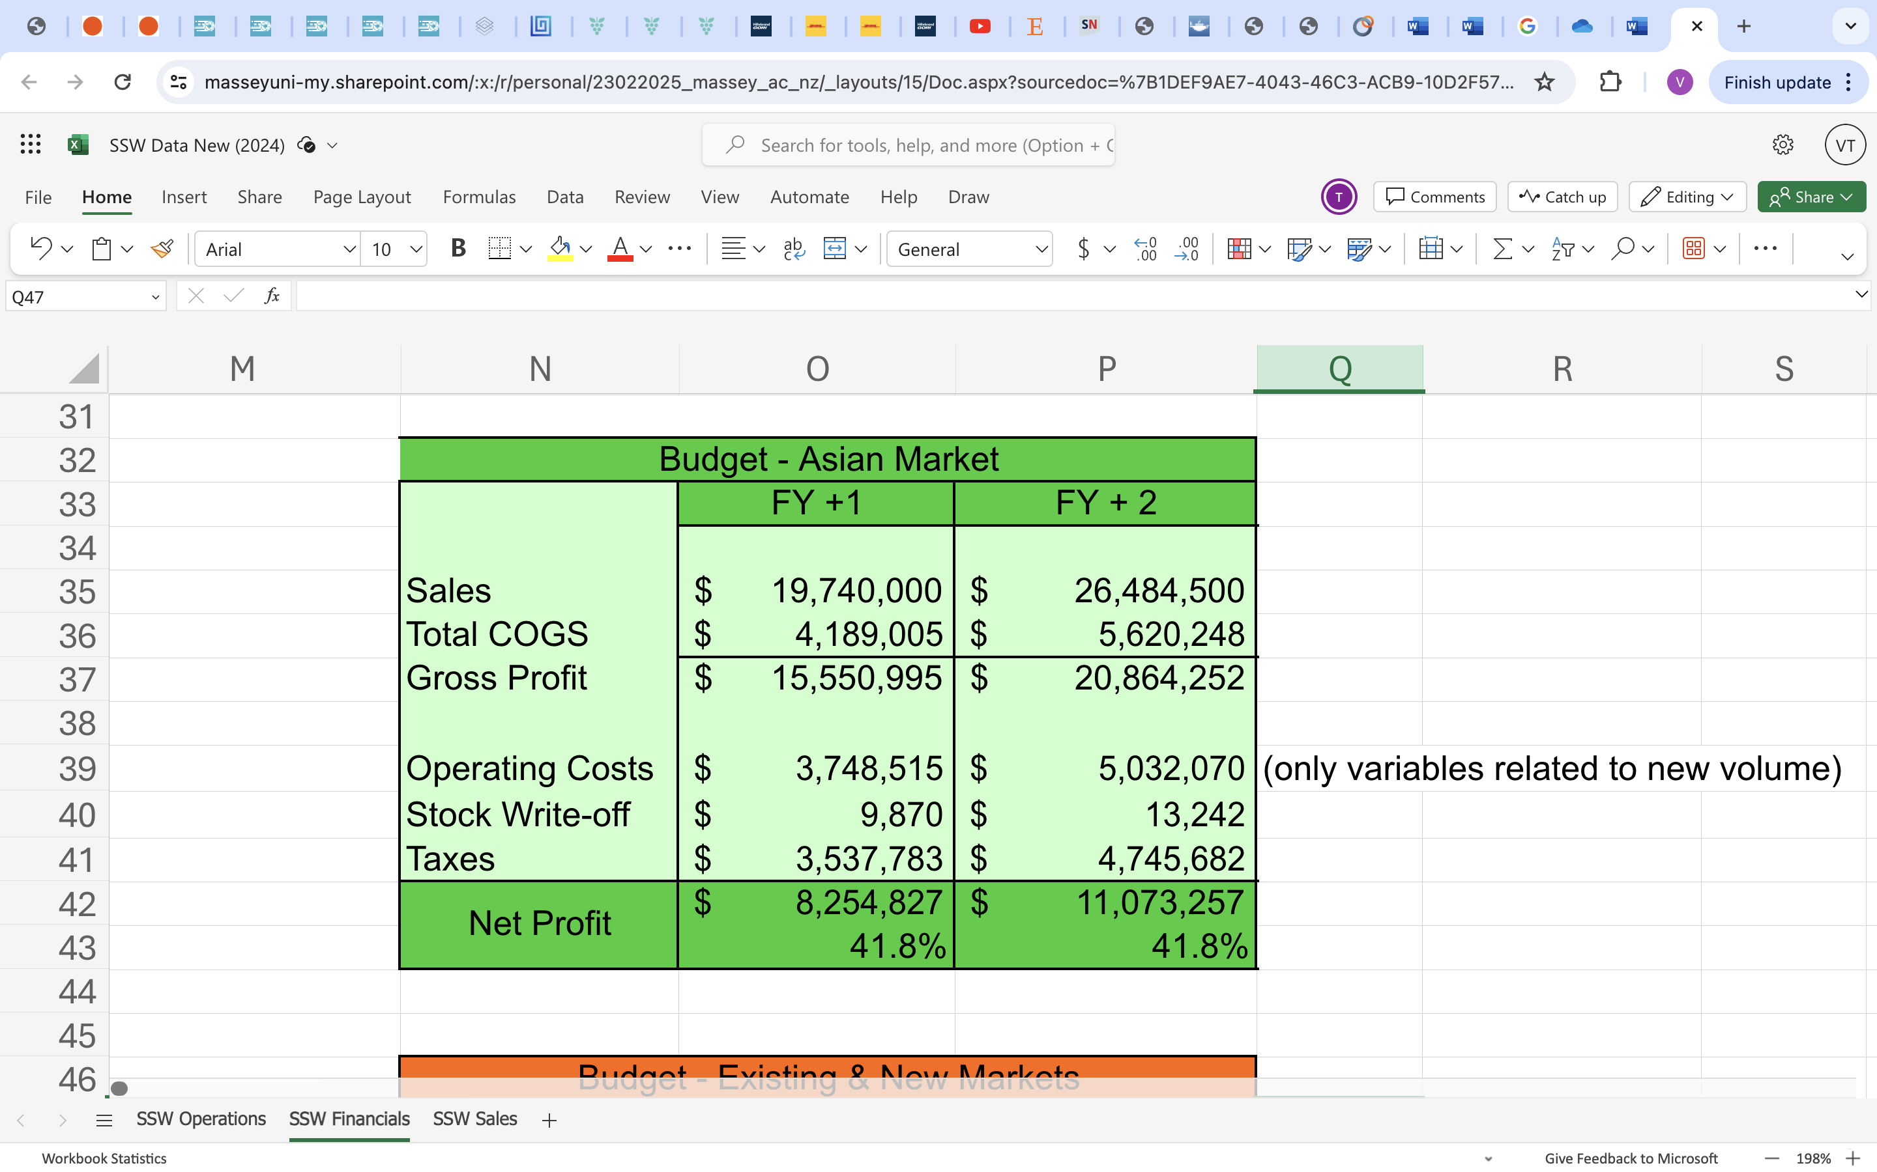

In Figure 12B below, there are cost breakdown details related to this new sales volume development.

Figure 12 B – Budget Cost for Year 1 and Year 2

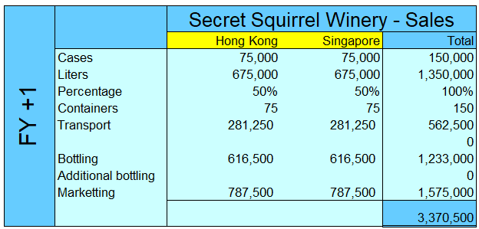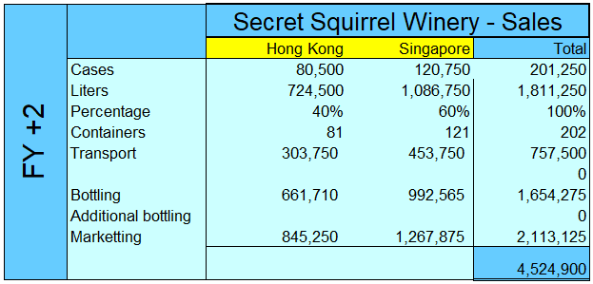

Figure 12 C – COGS Budget for Year 1 and Year 2

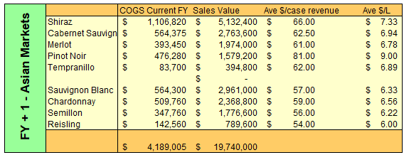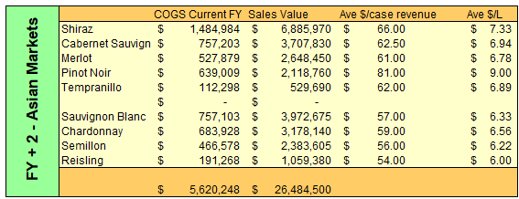  
Above tables in Figure 12 C illustrate the calculation of total sales value and the total Cost of Goods Sold (COGS) value for the next financial year and the following year which are used to calculate the profit margin.

***Combined financial results***

Finally, here is the combined financial results for both strategies put together shown in the Figure 13 below.

Figure 13. Combined Budget for FY1-FY2

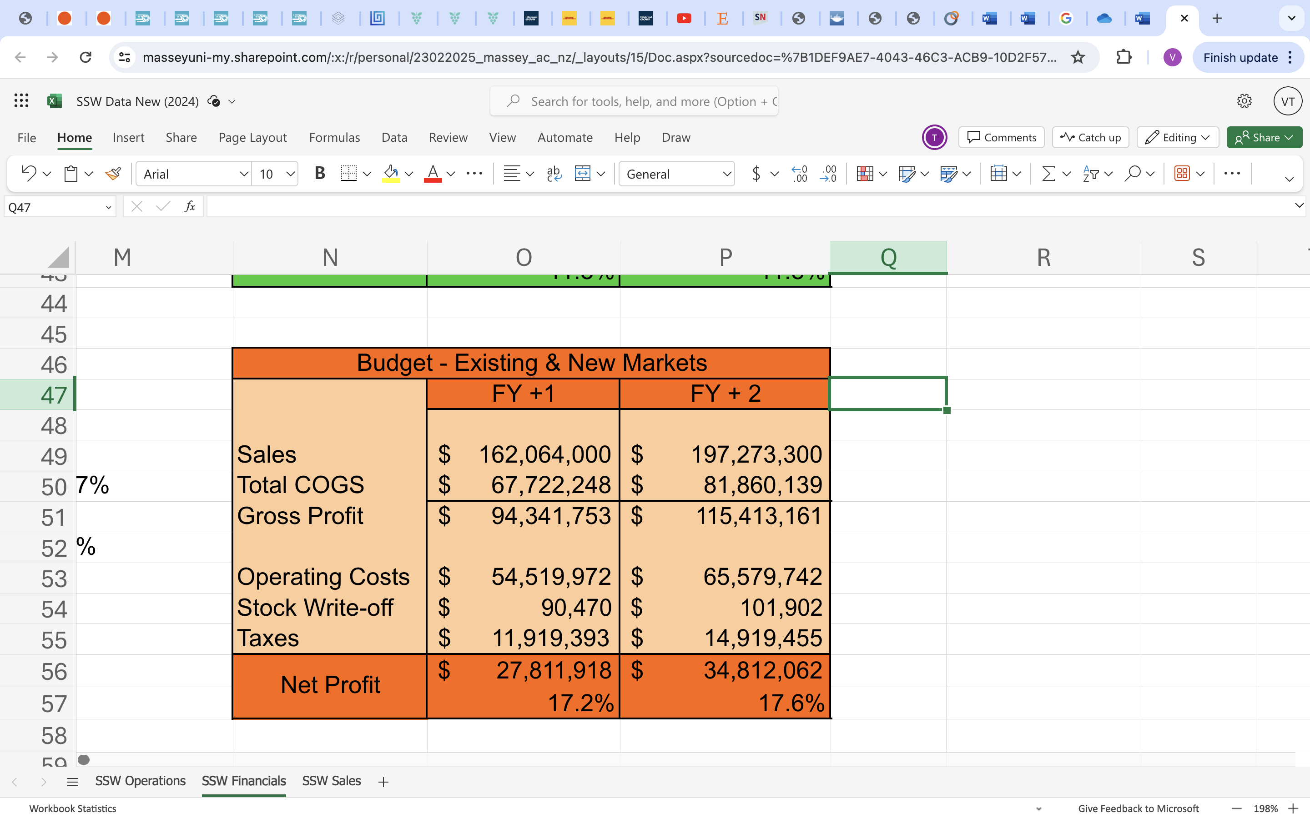

As shown, our combined solution significantly improves the bottom line, delivering the profit margin at average of 17%. Based on the effect of operating cost optimization and new sales growth driven by the premium product, our proposed solution is proven to deliver a significant value for SSW business and their shareholders in the next 2 years, reaching the net profit of $27,811,918 in the first year and $34,812,062 in the following year.

**Conclusion**

World Class Consulting, have researched, analysed and summarised the market findings to finalize our solutions for Secret Squirrel Winery. The usage of Flexitanks enables us to gain a net profit margin of 17% in just two years from a low 5%. This way we can save costs and expedite shipment. Flexitanks are highly sustainable and reduce energy consumption, carbon footprint and are environmentally sustainable as a mechanism of exporting wine all over the world. Moreover, the Asian market is the fastest growing wine markets. The export of premium wines that include Winemakers Selection and Chairmans Single Vineyard Selection to Asian markets through two major hubs Singapore and Hong Kong, who have free trade agreements with Australia will significantly increases profit. Overall, a consolidated 17% of profit margin and company growth is shown, thus ensuring that the consultancy effort, recommendation and implementation plan is successful in its objective of ensuring 20% growth within the two years.

**References**

Aaltonen, A. (2015). *How are flexible tanks becoming a solution for wine in bulk transportation?* <https://www.theseus.fi/bitstream/handle/10024/101377/Aaltonen_Alisa.pdf;jsessionid=E4315385E10414E2D98E63623B52380D?sequence=1>

Anderson, K. (2000). Export-Led Growth: Lessons from Australia's Wine Industry. *Rural Industries Research and Development Corporation*.

Anderson, K. (2020). Asia’s emergence in global beverage markets: The rise of wine. *Singapore Economic Review. 65*(04), 755-779. <https://www.worldscientific.com/doi/abs/10.1142/S0217590820500162>

Anderson, K., & Wittwer, G. (2015). Asia's evolving role in global wine markets. *China Economic Review*. 35:1-14.

Boriraj, J. (2008). Analysing and modelling international trade patterns of the Australian wine industry in the world wine market*.* *Other Degree thesis, Victoria University*.

Chiatti. (2024, March). Global Market Report March 2024. *Volume 15, Issue No. 3.* [https://e3g4ch2i44f.exactdn.com/wp-content/uploads/2024/03/Global-Market-Report- March-2024.pdf](https://e3g4ch2i44f.exactdn.com/wp-content/uploads/2024/03/Global-Market-Report-%20March-2024.pdf)

Fleming, E., Mounter, S., Grant, B., Griffith, G., & Villano, R. (2014). Performance trends in wine production in major wine exporting countries in the 2000s and their implications for the Australian wine industry. *Wine Economics and Policy* *3*(2)115-126.

Gwynne, R.N. (2008). UK retail concentration, Chilean wine producers and value chains. *Geographical Journal, 174:* 97-108. <https://doi.org/10.1111/j.1475-4959.2008.00276.x>

Rainer, G., Steiner, C., & Pütz, R. (2023). Market Making and the Contested Performation of Value in the Global (Bulk) Wine Industry. *Economic Geography*, *99*(4), 411–433. <https://doi.org/10.1080/00130095.2023.2200160>

Rainer G, Pütz R, Steiner C. (2021, December). The emergence of new wine design practices: Flexitanks and the assembling of bulk wine across global rural regions. *Geographical Journal*. Volume 187, Issue 4. 373–385. <https://doi.org/10.1111/geoj.12337>

Walter, C. L., & Cohen, B. C. (2006). Trends versus cycles in Global Wine Export Shares. The *Australian Journal of Agricultural and Resource Economics*.

Wine Australia. (2023). *Export Market Guides.* <https://www.wineaustralia.com/selling/export-market-guide-korea>

Wine Australia. (2023). *Global Markets.* <https://www.wineaustralia.com/market-insights/global>

Wine Australia. (2023). *Trade Agreements.* <https://www.wineaustralia.com/whats-happening/stories-of-australian-wine/april-2016/free-trade-agreements-in-japan-and-south-korea-w>

Wine Australia. (2023). *Export Report, 12 months to 31 December 2023.* <https://www.wineaustralia.com/getmedia/33939247-d765-4f26-ab7e-45241f04ed7e/Export-Report-MAT-December-2023.pdf>

Yung, J. Y., Saliba, J. A., MacDonald, J. B., Prenzler, P., & Ryan, D. (2013). A cross cultural study of wine consumers with respect to health benefits of wine*. Food quality and preference*. *28*(2),531-538. <https://www.sciencedirect.com/science/article/abs/pii/S0950329313000025>